Text Mining: Death Row Final Statements



Veasna Oum, Joe Amico, Stephanie Cruz, Vladimir Dinolov

Table of Contents

Introduction 2

Research Questions 4

Analysis 5

About the Data 5

Texas Inmates – Last Statements 5

Tarleton State 5

Models 8

K-Means Clustering 8

Clustering 8

K-Means Algorithm 8

Visual Exploration 9

K-Means Cluster Analysis 9

PCA for Scatter Plot 9

Evaluation with Unlabeled Dataset 10

Clusters Assignment of Text Document 10

WSS – Elbow Method 11

Rerun Clusters Analysis 11

Hierarchical Clusters Analysis 12

Divisive Method 13

HIERARCHICAL CLUSTERS DENDROGRAM 14

Naïve Bayes 15

Support Vector Machine 16

LDA Topic Modeling 16

Data Cleaning, Tokenization, and Vectorization 16

Model 1: Latent Dirichlet Allocation (LDA) 17

Decision Tree 17

Results 18

Clustering Results 18

Naïve Bayes 18

Support Vector Machine 21

LDA Topic Modeling 23

Decision Tree 23

Conclusions 24

Clusters Assignment of Text Documents 25

# Introduction

Capital punishment and the death penalty have a troubled history all over the world, including the Unites States of America. The practice was challenged in a number of legal cases in the 1960s resulting in no executions between 1968 and 1976. In 1972, the Supreme Court ruled that capital punishment violated a citizen’s Eighth Amendment right to not be subject to cruel and unusual punishment. However, in their ruling, the court allowed for the possibility of states to rewrite their capital punishment laws. A number of states, including Texas, rewrote their capital punishment laws to comply with the guidelines set by the Supreme Court and in 1976 the state court ruled to uphold these new laws. Following this decision, the number of executions began to rise, and today there are more than 3,000 people on death row, as compared to less than 500 prior to the ruling.

In 1982, Texas resumed executions and was the first state to perform an execution by lethal injection. Since then, Texas has executed 570 people, which is more than a third of the total amount of executions in the entire country during that time. Between that first execution after the courts’ ruling and March of 2017, 542 executions took place, and the final statements of each prisoner were recorded. During that same time, eight people who were possibly innocent were executed in Texas. Their statements were recorded as well. Each statement could provide insight into whether a prisoner was guilty or innocent, remorseful or resentful, and religious, grateful, or apologetic.

Final statements can be grouped by what is referred to as ‘sentiment’. Sentiment is a view or attitude toward a situation or event. A prisoner’s attitude towards the victim, family, or the justice system can be analyzed using sentiment analysis. Sentiment analysis is the contextual mining of text, which identifies and extracts subjective information. Other techniques, such as topic modeling, will provide a clearer picture of what prisoners are expressing moments before their death. Finally, by completing this study, the hope is that innocence or guilt could eventually be gathered from last statements, resulting in a fairer and more equitable justice system, as race and location have everything to do with incarceration and execution rates.

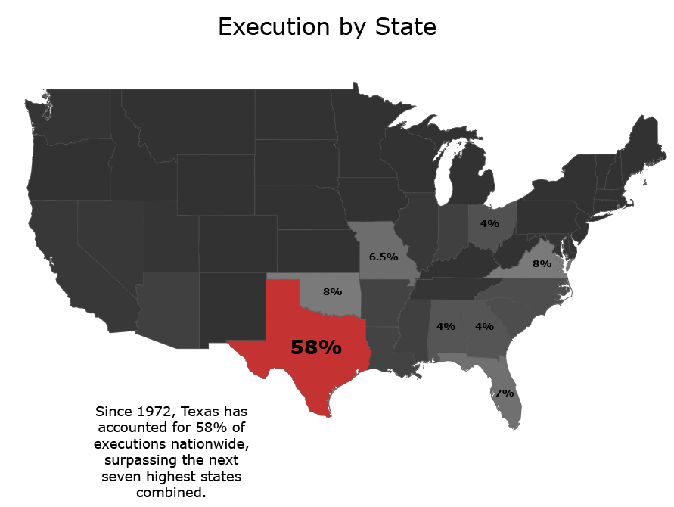*Figure 1. Executions Rates by State*

# Research Questions

The following questions were developed during exploration of demographic and text data:

* Arethere issues of inequity, racial or geographic, in Texas execution rates?
* Which words appear the most in final statements of executed prisoners?
* Can machine learning algorithms determine the sentiment of a statement as either remorseful, resentful, religious, grateful or apologetic?
* Does location affect the density of remorseful versus resentful final statements?
* What are final statement topics by U.S. regions? Is there variation?
* Can machine learning be used to predict final statement topics?

# 

# Analysis

## About the Data

### Texas Inmates – Last Statements

For this analysis, two datasets were acquired. The first data set was acquired from Kaggle and included the last statements of 545 death row inmates. The information in that data set includes: last name, first name, age, race, county of conviction, age when received, education level, and native county. For each statement, a label was added as to the statement of either ‘Remorseful’, ‘Resentful’, or ‘Other’.

### Tarleton State

The data gathered for this project was web scraped from a webpage hosted on Tarleton State University’s website (<https://www.tarleton.edu/scripts/deathrow/>). The website is a repository of over 1000 last statements from numerous states within the United States. The website lists information such as name, gender, plea, state, dates of the crime and execution, and the last statement they provided prior to their execution.

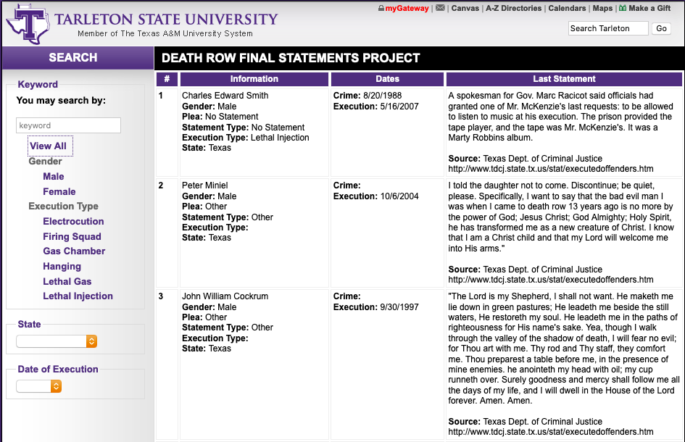

*Figure 2. Tarleton State Death Row Final Statement Screenshot*

#### Web Scape and Transform the Data:

To web scrape the website, Selenium was utilized to create a browser to navigate to the website and interact with the necessary buttons on the website. Once all buttons had been pushed to show the websites full list of last statements, the HTML was copied as a variable into Python and then imported into a Pandas dataframe using the read_html function. Further cleaning was required to fully separate the HTML table data into individual columns but eventually resulted in the following dataframe containing 11 columns and 1339 rows.

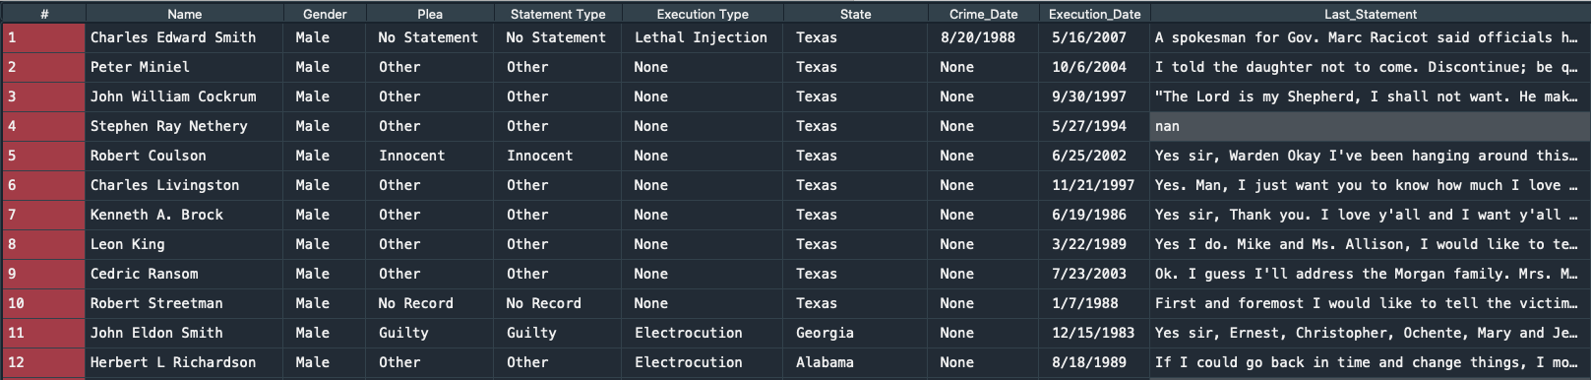

*Figure 3. Screenshot of Web Scraped Data in Pandas Dataframe*

#### Data Cleaning and Dataframe Construction:

The CSV obtained from web scraping the Tarleton University website was imported into a Pandas dataframe and was further cleaned. First, all rows that did not contain data within the last statement column were removed. Next, all punctuation was removed through the use of a replace function and regular expressions. Finally, it was attempted to remove Last Statements that indicated that a statement wasn’t given by removing last statements that contained only “decline”, “none”, “no statement”, “no record”, “made no final statement”, and “written”. The resulting CSV contained 904 rows.

Next, the reduced data was joined on an excel sheet that was sourced from the US Census Bureau at <https://www.census.gov/geographies/reference-files.2019.html>. This excel sheet provides the breakdown of the United States by Division and Region among other information. For this analysis, US Region and Division was joined on the state of each last statement. A portion of the resulting dataframe can be seen below.

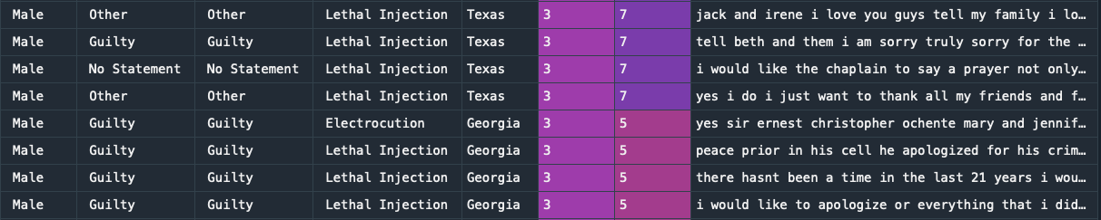

Figure 4. Screenshot of Reduced Dataframe with Census Data

The data was then imported into lists using a loop with the split function to split the data on the commas created by the CSV and placed into list by region. The split of the data by region can be seen in the bar plot below.

*Figure 5. Execution Data by Region*

#### Data Cleaning, Tokenization, and Vectorization

The data was now ready for tokenization and vectorization. CountVectorizer is a member of the sklearn library that supports the tokenization, vectorization, and removal of stop words from text data. The meaning of these terms are:

* Tokenization: Breaking strings of text data into single objects such as individual words. Token parameters can be applied to gather n-grams and to parse on specific characters to better tokenize datasets.
* Vectorization: Counting the number of instances a token appears and placing that data into a sparse matrix. This matrix is stored as a tuple where each column represents an individual token and each row represents the file or object the text was pulled from.
* Stop word Removal: Removing instances of stop words that are determined by the default setting of the model or through custom stop word lists. Stop word examples include words such as “and”, “the”, “him” which are believed to not have any significant value to the analysis of the text data.

Four vectorization models were built for use in this project’s analysis which included two models that used hard counts of words and two Tfidf models. The first model created was the best performing model for this project and will be the only one discussed in detail. Prior to building the CountVectorizer model, a function was created called *preprocess_text* which would be passed into the CountVectorizer model to remove numeric data from the statements. The code for the function can be seen below.

def preprocess_text(text):

text = text.lower()

text = re.sub(r'\d+', '', text)

return text

Three CountVectorizer models were then built for each regions data; one of the three can be seen below.

Region2_CV = CountVectorizer(input='content'

, strip_accents = 'unicode'

, stop_words = 'english'

, preprocessor = preprocess_text)

The last statements were passed to the CountVectorizer models and then turned into dataframes. The resulting head of the dataframe for Region 2 can be seen below.

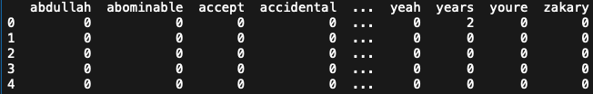

*Figure 6. CountVectorized Last Statements in Dataframe Configuration for Region 2*

# Models

## K-Means Clustering

### Clustering

Clustering is a Machine Learning technique that involves the grouping of data points. These data points analysis indicates which groups or categories they belong to. Those groups can then be generalized by the types of characteristics analysis that can be attributes or associate with those groups. Groups are defined by their similarities or dissimilar via their distance in the Euclidean Space; that is how far apart are the data points from each other and from their centroid, the center mean of the cluster

### K-Means Algorithm

1. Data points are plotted onto the Euclidean Space
2. Initial Centroids are assigned
   1. For K-Means algorithm the user must select the number of K = # Centroids
3. Each point will compute the distance to those Centroids. The data points will be assigned to the closest Centroid
4. Recompute the group center (Centroid)
5. Reiterate the process until the Centroid converges. The mean value of the Centroid should not change
6. Classification is complete

### Visual Exploration

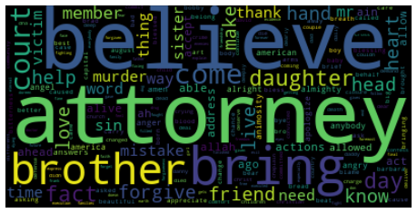

*Figure 7. Word Cloud of Key Words for Cluster Analysis*

### K-Means Cluster Analysis

*K = 3;* this is the number of clusters chosen as the initial clusters and from the cluster’s analysis, the dataset can be grouped into: *Remorseful, Resentment and Other*

### PCA for Scatter Plot

The Python script uses Principal Component Analysis to reduce the features to 2 dimensions for scatter plots



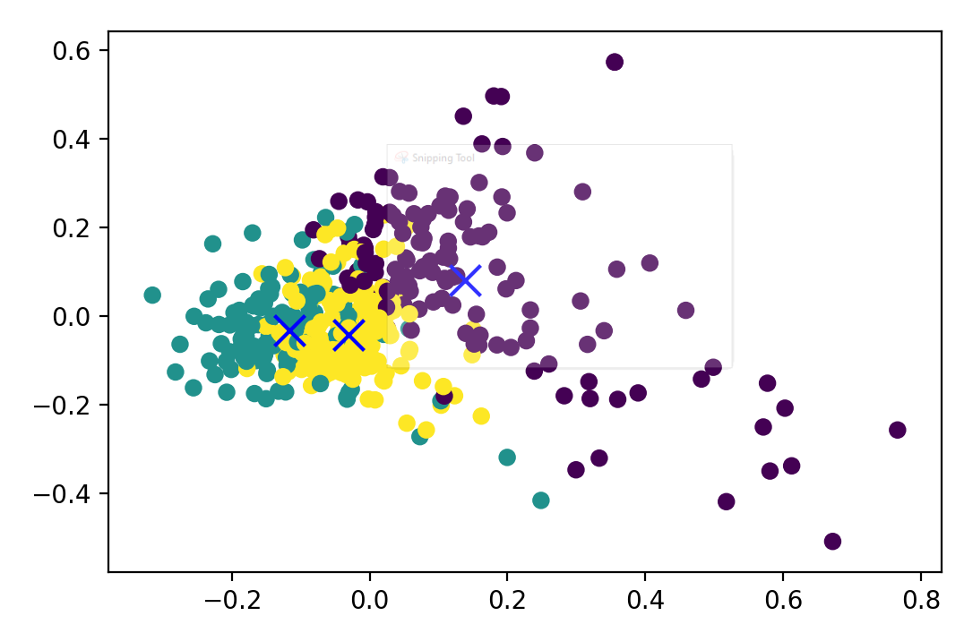

*Figure 8. Three Overlapping Clusters: Remorseful, Resentment, and Other*

The analysis appears to show overlapping clusters with several outliers that can be defined as its own clusters.

### Evaluation with Unlabeled Dataset

The Silhouette Coefficient is calculated using the mean intra-cluster distance (a) and the mean nearest-cluster distance (b) for each sample. The Silhouette Coefficient for a sample is (b - a) / max (a, b). To clarify, b is the distance between a sample and the nearest cluster that the sample is not a part of.

The best value is 1 and the worst value is -1. Values near 0 indicate overlapping clusters. Negative values generally indicate that a sample has been assigned to the wrong cluster, as a different cluster is more similar.

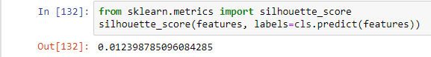

*Figure 9. Silhouette Coefficient Calculation and Results*

The value means that our clusters are overlapping. We can also see this in the plot above. Perhaps tuning different parameters for feature extractor and the clustering model will increase this score

### Cluster Assignment of Text Documents

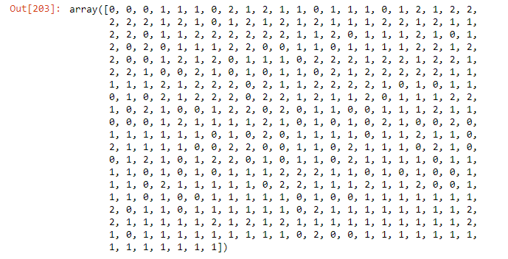*Figure 10. Cluster Assignment of Text Documents*

The array maps the text documents to one of the three assigned clusters in the Scatter plot. 0 indicates the first cluster and 1, 2 are second and third clusters, respectively.

### WSS – Elbow Method

Using to the Within Sum or Square method (WSS) to find the right number of clusters. WSS -Elbow Method is a balanced between choosing the size of clusters compared to their sum of errors from the residuals. We found from the first investigation into the dataset that the clusters can be labeled as *Remorseful, Resentment and Other.*

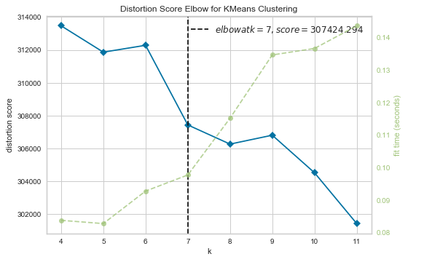

*Figure 11. WSS Elbow Method: Recommend Number of Clusters*

WSS suggested that the right number of clusters should be at 7. Further examination of the dataset, it seems to be the case that the labels can be re-evaluate as the labels below. The groups were also validated by Topic Modeling Analysis in predicting the sentiments of the text.

**Labels**

1. *Remorseful*
2. *Resentment*
3. *Other*
   1. *Innocent*
   2. *Religious*
   3. *Short statement*
   4. *Appreciative statement*
   5. *Mournful*

### Rerun Clusters Analysis

*PCA applied to dataset*

*K = 7*

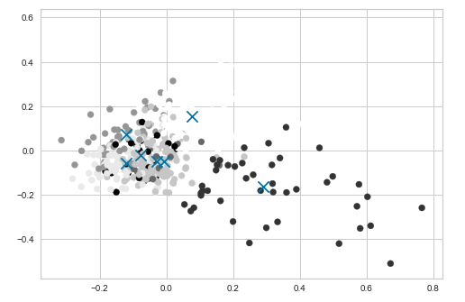

*Figure 12. Second Cluster Analysis with Seven Clusters*

### Hierarchical Clusters Analysis

The goal of hierarchical cluster analysis is to build a tree diagram where the pairs or groups that were most similar by sentimental analysis are close together. Some pairing of texts is overlapping as the sentiment are not as define. The key to interpreting a hierarchical cluster analysis is to look at the point at which any given pair of text documents “join together” in the dendrogram. Texts that join together sooner are more similar to each other than those that join together later.

The lower level of the diagram depicts the closest in sentiments and term frequency, while the moving up the level-tier becomes shallower in resembling the sentiment of the text. From the mid-level clusters towards the bigger clusters means that there can be a lot of overlapping in the system.

Hierarchical clustering involves creating clusters that have a predetermined ordering from top to bottom. For example, all files and folders on the hard disk are organized in a hierarchy. There are two types of hierarchical clustering, *Divisive* and *Agglomerative*.

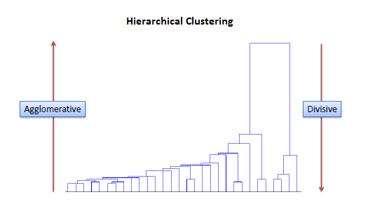

*Figure 13. Example of Agglomerative and Divisive Hierarchical Clustering*

### Divisive Method

In divisive or top-down clustering method we assign all of the observations to a single cluster and then partition the cluster to two least similar clusters. Finally, we proceed recursively on each cluster until there is one cluster for each observation. There is evidence that divisive algorithms produce more accurate hierarchies than agglomerative algorithms in some circumstances but is conceptually more complex.

### HIERARCHICAL CLUSTERS DENDROGRAM

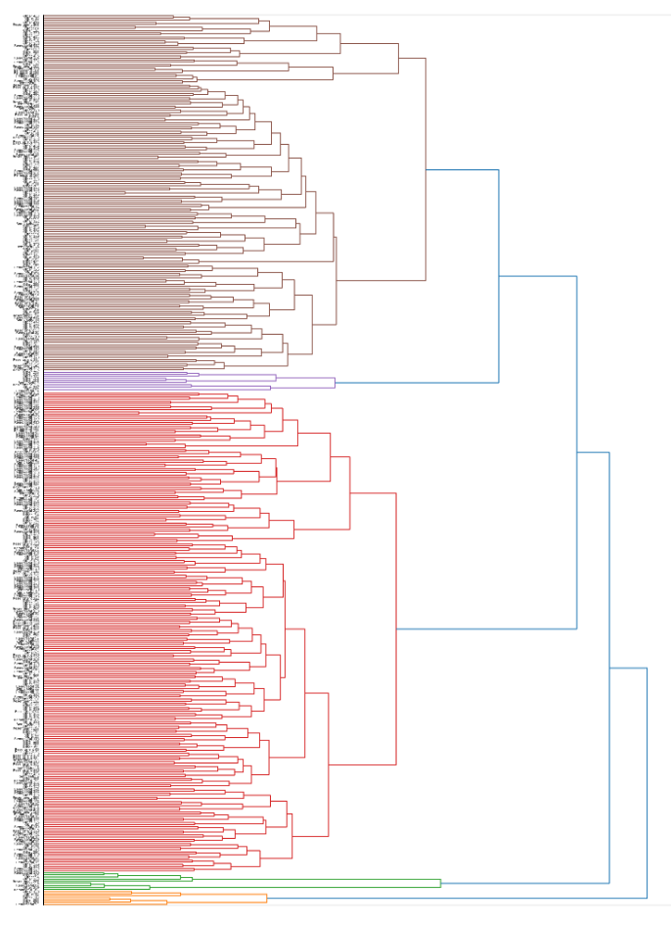

*Figure 14. Dendrogram of Hierarchical Clusters*

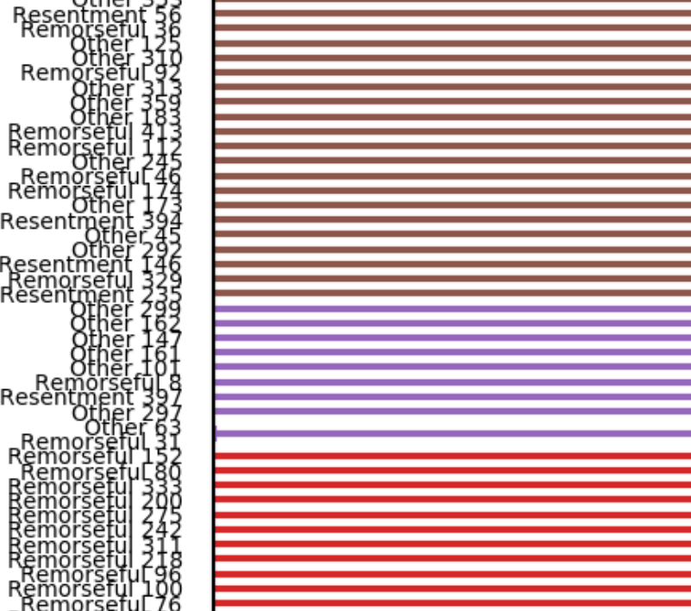

*Figure 15. Pairings and Groupings of Text Documents*

Zooming into the Hierarchical Clusters dendrogram shows the pairing and grouping of text documents.

## Naïve Bayes

To determine whether a final statement was ‘Remorseful’, ‘Resentful’ or ‘Other’, a Naïve Bayes classifier was used. Initially, the model attempted to predict between all three categories. However, that resulted in only a sixty percent accuracy rate. This low accuracy rate likely occurred because the statement in the ‘Other’ category have a wide range of topics.

In an attempt to improve the accuracy rate, the ‘Resentful’ and ‘Other’ statements were simply classified as ‘Not Remorseful’. Both a CountVectorizer and TfidfVectorizer were used, removing ‘english’ stop words. This new data set was split into training data and testing data with thirty percent of the data being used as testing data and the rest being used as training data. A multinomial Naïve Bayes model was used to fit the data and a confusion matrix was created to visualize the prediction results.

## Support Vector Machine

A support vector machine was also used to predict ‘Remorseful’ or ‘Not Remorseful’. Three different models were used. All three models used a 30% of the data for testing and 70% for training. One of the models used a linear kernel, one used a polynomial kernel with degree of ‘3’ and cost value of ‘50’, and the third used a radial kernel with a cost of ‘10000’.

## LDA Topic Modeling

Latent Dirichlet Allocation is an unsupervised ML model that creates Dirichlet distrubutions for words to classify a user-specified number of topics in a given body of text. So, if a user states that there are four topics in the text, the model will create four different “topics” with the weights of the words for those given topics. Based off those weights, the documents can then be classified into what topic they belong to. For this project, the following model was utlized to create the best result for the given data.

**LDA Model Region 2**:

num_topics = 2

max_iterations = 1000

## lda_model_region2 = LatentDirichletAllocation(n_components=num_topics

## , max_iter=max_iterations

## , learning_method='online'

## , verbose = 1

## , random_state = 10)

**LDA Model Region 3**:

num_topics = 4

max_iterations = 1000

## lda_model_region3 = LatentDirichletAllocation(n_components=num_topics

## , max_iter=max_iterations

## , learning_method='online'

## , verbose = 1

## , random_state = 10)

**LDA Model Region 4**:

num_topics = 2

max_iterations = 1000

lda_model_region4 = LatentDirichletAllocation(n_components=num_topics

, max_iter=max_iterations

, learning_method='online'

, verbose = 1

, random_state = 10)

## Decision Tree

A Decision Tree classifier was also used to see if a topic can be predicted from the word usage in a final statement. Once again, the dataset that combined ‘Resentful’ and ‘Other’ into one group was used for this model. A test group of thirty percent of the data was used for this model as well. The max depth for the decision tree was set at ‘4’ levels.

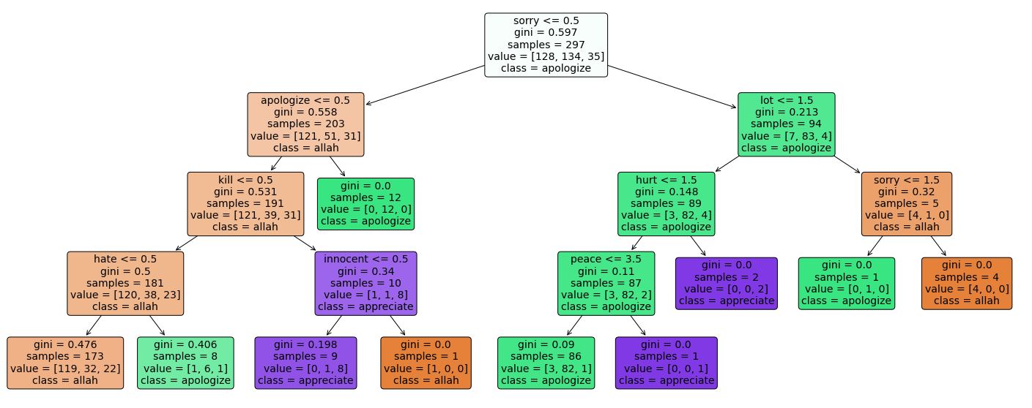

*Figure 16. Topic Decision Tree for Classifying Resentful and Other Statements*

Above, the produced three can be seen. Based on the words in the document, the following topics were found: ‘apologize’, ‘allah’, and ‘appreciate’.

# Results

## Clustering Results

Clusters size were found to be optimal between 5 and 7 clusters for the “Last Statement”, text sentimental analysis.

## Naïve Bayes

The initial Naïve Bayes model, that predicted between ‘Remorseful’, ‘Resentful’, and ‘Other’ only predicted with ~60% accuracy. The second model, that grouped ‘Resentful’ and ‘Other’ together, and predicted ‘Remorseful’ and ‘Not Remorseful’ was much more accurate.

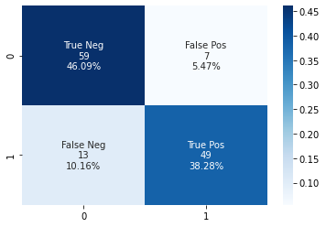

*Figure 17. Confusion Matrix of Naïve Bayes Results*

Based on the confusion matrix above, it can be seen that the accuracy for the second model is about 84%.

Various counties in Texas had different rates of remorseful vs. resentful statements. Below it can be seen that the counties with the most resentful statements are Bailey, Harrison, Nacogdoches and Wood counties. The counties with the most remorseful statements are Hunt, Kendall, Madison, Polk, Refugio, Sabine, Trinity, and Wharton.



*Figure 18. Most Remorseful and Resentful Counties in Texas*

## Support Vector Machine

The support vector machine with a linear kernel predicted ‘Remorseful’ or ‘Not Remorseful’ with about 73% accuracy.

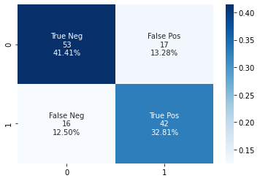

*Figure 19. Confusion Matrix for Support Vector Machine Results – Linear Kernel*

The support vector machine with a polynomial kernel predicted ‘Remorseful’ and ‘Not Remorseful’ with about 67% accuracy. It was less accurate than the model with the radial kernel and had a large number of false negatives (33).

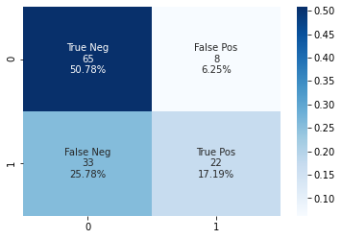

*Figure 20. Confusion Matrix for Support Vector Machine Results - Polynomial*

The support vector machine with a radial kernel predicted ‘Remorseful’ and ‘Not Remorseful’ with about 64% accuracy. It was the least accurate model. None of the support vector machine models predicted ‘Remorseful’ or ‘Not Remorseful’ as accurately as the Naïve Bayes model.

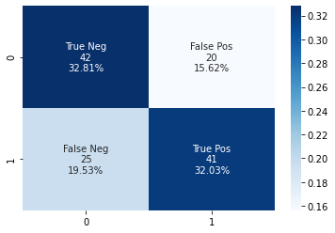

*Figure 21. Confusion Matrix for Support Vector Machine Results - Radial*

## LDA Topic Modeling

*Figure 22. LDA Topic Modeling Results by Region*

### Region 2

Given the size of Region 2 (named South in the diagram) four topics was found to be the best fit for the model. Topic 2 appeared to be a final address where the inmate was giving their final statements to their family and to god. Topic 3 was a more religious topic where the words that appeared in the topic appeared to be something someone would find in scripture or other religious text. Topic 4 appeared to capture remorse and thankfulness which they wanted people in their life to know. Topic 1, the least intuitive of the four, took manual investigation of the dataset to understand what the topic was capturing. After investigation, it was discovered that the majority of the words found in this topic are found in very short statements. Some include Muslim prayer, others were text that described the scene of the last statement, and the last portion were none statements from the inmate that weren’t able to be cleaned out of the data set.

### Region 3

Region 3 (Midwest) is the next largest area in terms of data for last statements. This region produced the best results with two topics. Topic 1 appeared to be asking for forgiveness and showing sorrow for their actions to those that they had affected. Topic 2 appeared to be asking for forgiveness from their family and from God / Jesus.

### Region 4

Region 4 (West) was the smallest of the regions in terms of data and performed best with two topics. Interestingly, the two topics that were created were very similar to the first two topics of Region 2.

### LDA Conclusion

LDA was able to detect differences in topics between the three of the four regions of the United States that was available in the Tarleton dataset. Further analysis of the different divisions has the potential to yield interesting results and may be a better technique to create topics with Region 2 given its size and overwhelmingly larger sample size in comparison to the other regions. Lastly, more interesting results could be created through a more dedicated cleaning process to ensure that none-statements are not included in the dataset. Most likely, this would require a line-by-line scrub of the dataset as the dataset was already reduced from approximately 1300 rows to 904.

## Decision Tree

The decision tree predicted topic with only a 50% accuracy. The results from the decision tree analysis are shown below. More work needs to be done to try and improve the accuracy of this model.

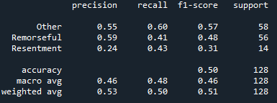

*Figure 23. Decision Tree Results: Precision, Recall, F-1 Score, Support*

# Conclusions

The death penalty is a contentious topic, leading many to have opinions about moral correctness versus poetic justice. Regardless of opinions, one fact is certain: Texas leads the nation in the number of executions taking place since 1972. The state’s culture and outlook on the death penalty can be summed up by one of the offenders from the data set, Mark Stroman, who in his final statement said: “I am still a proud American, Texas loud, Texas proud. God bless America, God bless everyone. Let's do this damn thing.” Final statements, such as Mark Stroman’s, were analyzed to assign and classify statements by sentiment and synthesize topics by U.S. regions. Through this analysis, it was determined that predicting if a final statement was remorseful or not could be predicted at a higher rate of accuracy than predicting the topic of the statement based off the words contained in it.

Sentiment, as denoted by feelings of remorse, resentment, gratitude, sorrow, righteousness, and guiltlessness, were identified using keywords and associations like ‘thank’, ‘lord’, ‘brother’ ‘friend’, ‘forgive’, ‘mistake’, ‘sin’, ‘believe’, ‘anger’, and ‘allah’. Feelings of remorse were classified and predict at the highest accuracies. The same themes translated to topics as well, with all regions having either religion, forgiveness, or gratitude included in regional topics. The difficulties in predicting topic could be related to the sample sizes of data by region, the skewness of the data towards the southern region of the United States, and similarity in words used to communicate topis and emotions often associated, such as forgiveness and religion. To enrich this study and improve the acquisition of accurate data, next steps would include interviewing death row prisoners awaiting execution, creating transcripts, and using that data to complement the current data sets. Additionally, it would be essential to analyze final statements by race and identify rates of remorse, resentment, righteousness, gratitude, sorrow, and guiltlessness, the latter which would be of great interest due to the documented inequitable application of the death penalty.

According to the ACLU, the color of a defendant’s skin plays a crucial and unacceptable role in deciding who receives the death penalty in America. People of color have accounted for a disproportionate 43% of executions nationwide. While this report only researched Texas execution rates, countless reports spanning decades conclude that systemic racial bias in the application of the death penalty exists at both the state and federal level. In 1987, a Supreme Court case concluded that while the death penalty had “racially disproportionate impact”, it could not be proven without ‘intentional discrimination’. The case, McCleskey v. Kemp, is referred to as the case that made the criminal justice system immune to scrutiny relating to racial bias, essentially sending the message that the Equal Protection clause from the 14th amendment does not apply to people of color unless discrimination can be proven, regardless of what data illustrates. Additionally, the court ruled that capital punishment does not violate the 8th amendment unless a racially discriminatory purpose can be proved.

One of the many next steps for this report would include an analysis of national death penalties by race and study the effects of location, socioeconomic status, and access to food, healthcare, and affordable housing. As of 2020, 12 offenders have been executed with four more scheduled before 2021. Of those 16 offenders, 50% are people of color.



*Figure 24. Texas Executions by Race and Population*



*Figure 25. Texas Counties by Number of Executions*